API Integration

- API Integration : making HTTP requests and error handling

1. Choosing an HTTP Client

Fetch API (Built-in)
      - comes built into React Native
      - sufficient for basic needs
      - Promise-based

      - No automatic JSON parsing (must call .json())
      - No request cancellation by default (requires AbortController)
      - Basic error handling (only rejects on network failures)

Axios (Popular Third-party)
      - Automatic JSON transformation
      - Request/response interceptors
      - Request cancellation
      - Timeout support
      - Better error handling (rejects on non-2xx status codes)

When making HTTP requests in React Native, developers commonly choose between
fetch and axios.
Both serve the purpose of fetching data from APIs,
but they differ in their features and usage.

Fetch
fetch is a built-in JavaScript API for making network requests. It is promise-based and relatively straightforward for basic use cases.

Pros:
- Native to JavaScript, no external library required.
- Simple syntax for basic GET requests.
- Widely supported by modern browsers.
Cons:
- Requires manual handling of error handling and JSON parsing.
- Lacks advanced features like request cancellation and interceptors.
- Not supported by older browsers without a polyfill.

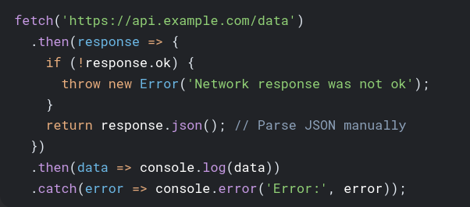

Axios
axios is a third-party library that simplifies making HTTP requests and managing responses. It offers a more feature-rich API compared to fetch.
Pros:
- Automatic JSON transformation of request and response data.
- Built-in error handling and request cancellation.
- Interceptors for request and response manipulation.
- Protection against XSRF attacks.
- Wide browser support, including older browsers.

Cons:
- Requires installation as an external dependency
- Larger bundle size compared to fetch.

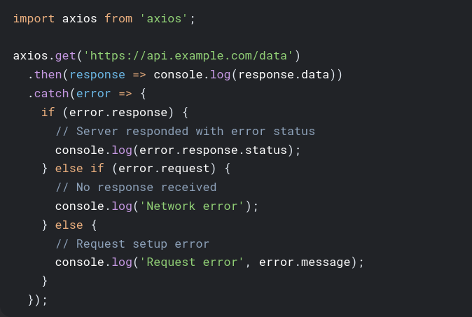

Choosing Between Fetch and Axios
The choice between fetch and axios depends on the specific needs of the project:
- For simple projects with minimal requirements, fetch might be sufficient due to its simplicity and lack of external dependencies.
- For larger, more complex projects, axios offers more advanced features and better error handling, which can improve development efficiency.
- If backward compatibility with older browsers is a concern, axios is a safer choice or fetch with a polyfill.
- If bundle size is a critical factor, fetch might be preferred, although the difference may not be significant in many cases.

Here's a comparison table summarizing the key differences:

Feature | Fetch | Axios
Native | Yes | No
Error Handling | Manual | Built-in
JSON Parsing | Manual | Automatic
Request Cancellation | Not Supported | Supported
Interceptors | Not Supported | Supported
XSRF Protection | No | Yes
Browser Support | Modern Browsers Only | Wide Support
Bundle Size | Smaller | Larger

- Ultimately, the best approach is to evaluate the project's requirements and choose the tool that best fits those needs.

- Install Axios

  - npm install axios

- Sample Example

const axios = require('axios'); // only default export is available

// Make a request for a user with a given ID
axios.get('/user?ID=12345')
.then(function (response) {
// handle success
console.log(response);
})
.catch(function (error) {
// handle error
console.log(error);
})
.finally(function () {
// always executed
});

async function getUser() {
try {
const response = await axios.get('/user?ID=12345');
console.log(response);
} catch (error) {
console.error(error);
}
}

🔹 Interceptors VS Middlewares
Feature | Middleware (e.g., Express.js) | Interceptor (Axios / Fetch)
📍 Scope | Server-side (Node.js backend) | Client-side (Browser or Frontend App)
🔁 Intercepts | Incoming HTTP requests to server and responses sent from server | Outgoing HTTP requests from frontend and responses from server to frontend
📦 Use Cases | Auth verification, input validation, routing, error handling | Adding auth tokens, showing loaders, logging, error catching
🛠️ Usage Context | Middleware chains in Express, Koa, etc. | Axios: axios.interceptors; Fetch: custom wrapper/interceptor logic
🕵️‍♂️ Visibility | Sees only backend-side HTTP traffic | Sees only frontend-side HTTP traffic

Action | Description | Purpose
Intercept Request | Catch request before it's sent | Add auth token, log, modify
Intercept Response | Catch response before it's used | Handle errors globally, log
Transform Request Data | Modify body or headers | Format payloads, encode data
Transform Response Data | Modify response data | Unwrap API structure, format output

2. Handling Asynchronous Operations

2.1 Promises
Promises represent the eventual completion (or failure) of an asynchronous operation.
Three States:
- Pending: Initial state
- Fulfilled: Operation completed successfully
- Rejected: Operation failed
Promise Chaining:
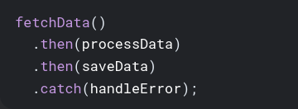

2.2 async/await
Syntactic sugar over Promises that makes asynchronous code appear synchronous.
Key Benefits:
- Cleaner error handling with try/catch
- Sequential-looking code
- Easier debugging (stack traces)
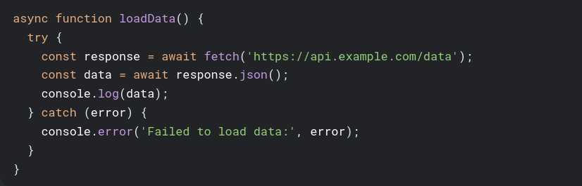

Error Handling Patterns:
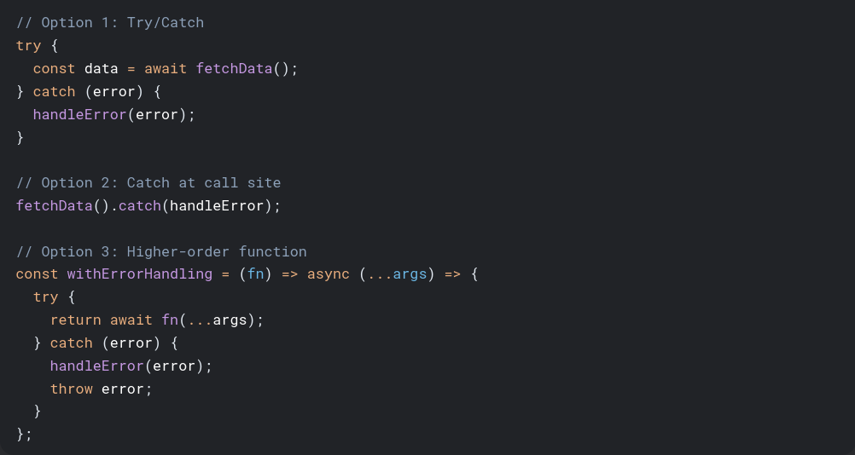

3. Consuming RESTful APIs

3.1 REST Principles
- Client-Server Architecture: Separation of concerns
- Stateless: Each request contains all necessary information
- Cacheable: Responses define cacheability
- Uniform Interface: Resources identified in requests
- Layered System: Intermediary servers possible

3.2 Common HTTP Methods
Method | Description | Idempotent | Safe
GET | Retrieve resource | Yes | Yes
POST | Create resource | No | No
PUT | Replace resource | Yes | No
PATCH | Partially update | No | No
DELETE | Remove resource | Yes | No

3.3 Status Code Categories
Code Range | Meaning
1xx | Informational
2xx | Success (200 OK, 201 Created)
3xx | Redirection
4xx | Client errors (400 Bad Request, 401 Unauthorized, 404 Not Found)
5xx | Server errors (500 Internal Server Error)

3.4 API Consumption Patterns
Basic GET Request:
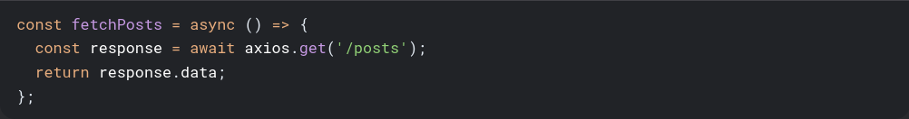
POST with Data:
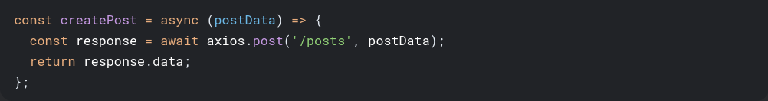
PUT for Updates:
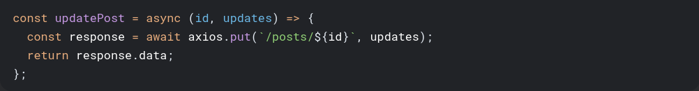
DELETE Request:


4. Error Handling and Data Parsing

4.1 Comprehensive Error Handling
Axios Error Structure:

Centralized Error Handler:


4.2 Data Parsing and Validation
Basic Validation:
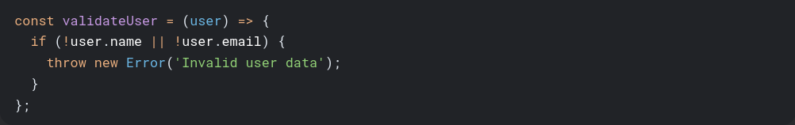
Using Zod for Schema Validation:

Transforming API Responses:
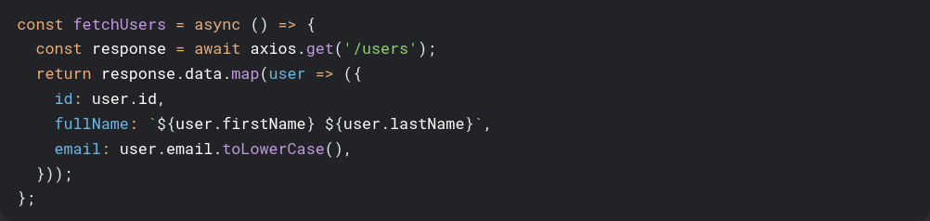

5. Advanced Patterns

5.1 Request Cancellation
Using AbortController (Fetch):
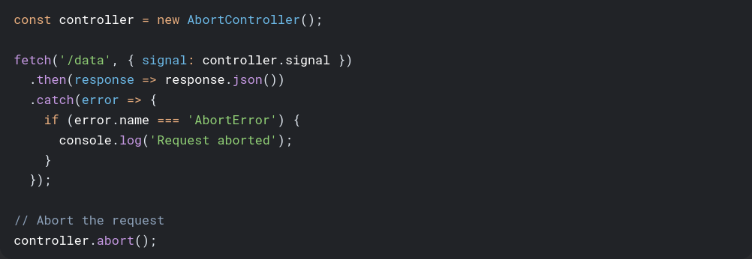
Using CancelToken (Axios):
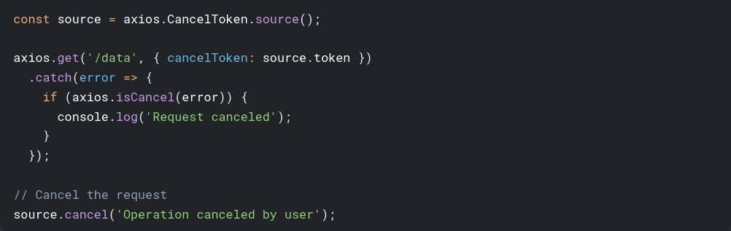

5.2 Retry Mechanism
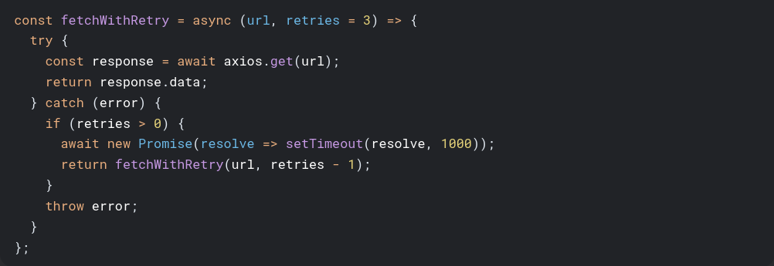

5.3 Request Debouncing
Debouncing API Calls: When implementing search-as-you-type
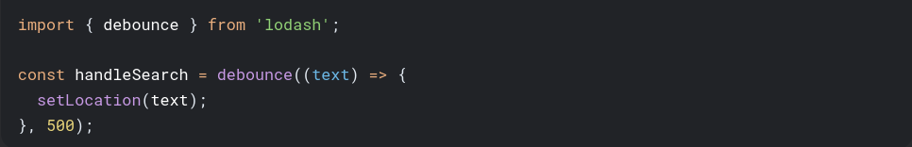
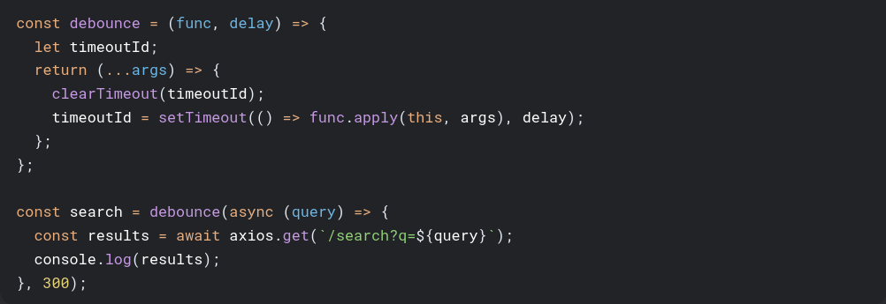

6. Security Considerations
- HTTPS: Always use encrypted connections
- API Keys: Store securely (not in client code)
- Input Sanitization: Prevent injection attacks
- CORS: Configure properly on server
- Rate Limiting: Handle 429 responses gracefully
- Authentication: Use secure tokens (JWT) with short expiration

7. Performance Optimization
- Caching: Implement response caching
- Batching: Combine multiple requests
- Pagination: Load data in chunks
- Lazy Loading: Fetch data as needed
- Compression: Enable gzip on server

- Reference DOCS
- Official Docs: React Native Networking
- Official Docs: Axios GitHub

